(Approx. 444 words)

Open Source Lab
GIMP 2.10
By Cal Esneault, Former President of CCCC and leader of many Open Source Workshops & SIGs
April 2020 issue, CCCC Computer News
www.clickers.org
tsa70785 (at) gmail.com

GIMP 2.10 GIMP, the GNU Image Manipulation Program, is an open-source image editor suitable for touching up photos or drawing original creations. GIMP has a long history (started in the 1990’s) and has continually been improved to become a very powerful and sophisticated tool.

Even version numbers (2.0, 2.2, 2.4, etc.) indicate stable versions, while odd version numbers are for developmental releases. Early in 2018, GIMP 2.10 was issued. This was long-anticipated since the previous stable version, 2.8, was over 6 years old. Unfortunately, this version was too late to be included in the Ubuntu and Linux Mint repositories, so users of these would need to go to the GIMP website to get the latest release.

I downloaded and installed GIMP 2.10 on my Windows PC (yes, GIMP is cross-platform). The first thing you notice is the dark theme and symbolic icons installed the default. Compare the previous 2.8 icons with the new set as shown below.

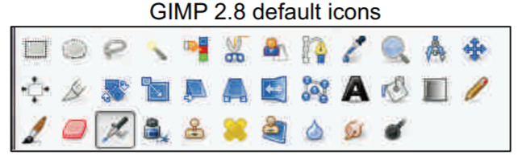
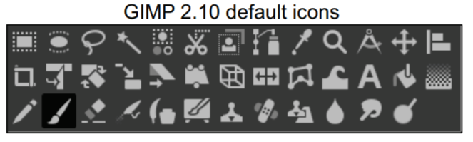

GIMP 2.8 default icons GIMP 2.10 default icons Originally, GIMP had multiple isolated activity windows, but GIMP 2.10, like GIMP 2.08, has a single-window mode that is similar to the interface for Photoshop. Following is a screenshot of GIMP with the main toolbox on the left, the image of interest in the middle, and a tool options panel on
the right. GIMP has the ability to have “layers,” and the example shown illustrates how this can be used to superimpose text on the image to indicate its location.

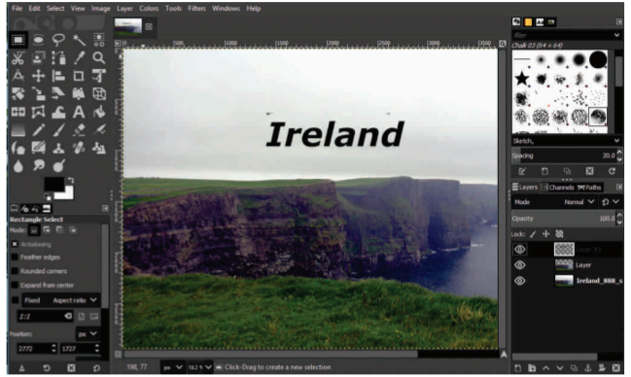

Experienced photographers often shoot in a “raw” image mode. Raw files must be preconditioned using a separate editor. GIMP 2.10 cooperates with two excellent raw editors – Darktable and RawTherapee. As noted by others, I could only get GIMP to behave on my Windows 10 system using Darktable.

Under the hood, the big change was further improvement of the GEGL processing engine. For now, this gives deeper color bit depth and better HiDPI support. The new icons are also a part of the process to give sharp icons on HiDPI monitors. Improved multi-threading makes better use of the multiple cores in modern CPUs. The full implementation of GEGL is a prerequisite for adding non-destructive editing (planned for v3.2). Color space workflow is improved, and native color management is now available.

There are numerous other advancements in this major release that should be of great use to serious photographers. Be sure to read the complete set of release notes to find out details on how to improve your creative work.

